**Sequence Diagram - Post Announcement**

Entity classes: Announcement

Boundary classes: AnnouncementView

Control classes: AnnouncementController

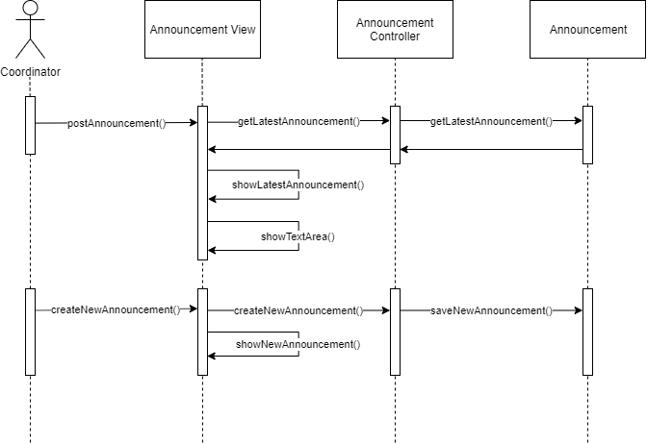

**Sequence Diagram - Search Information**

Entity classes: User, Message, Announcement

Boundary classes: SearchView

Control classes: SearchController

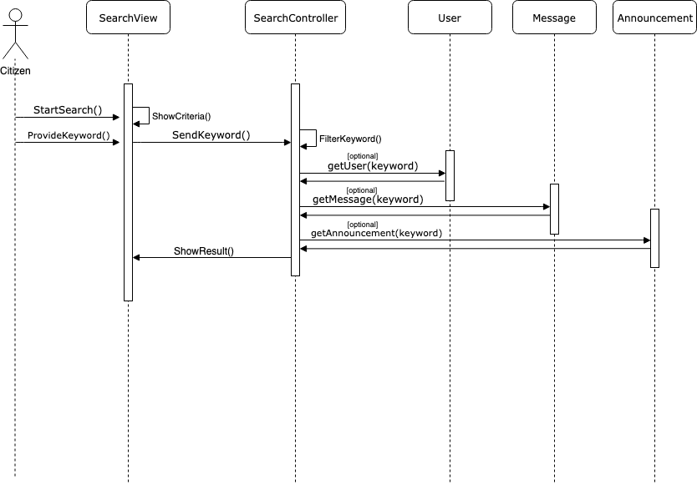

**Class Diagram - Post Announcement**

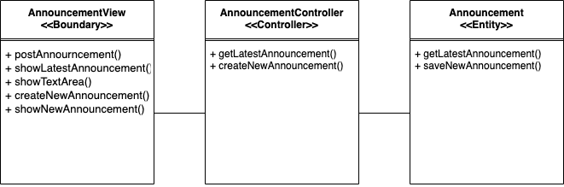

**Class Diagram - Search Information**

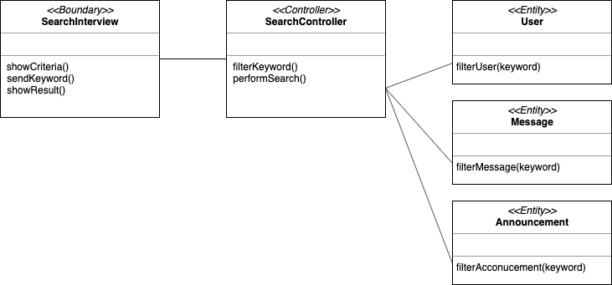

**Mapping between UML Diagram and Code Structure**

|  |  |  |
| --- | --- | --- |
| Analysis Class Type | Analysis Class | Corresponding Code Element |
| Boundary | AnnouncementView | frontend/page/announcement.js |
| SearchView | frontend/page/search.js |
| Control | SearchController | backend/controllers/chat.js |
| AnnouncementController | src/controllers/announcement.ts |
| Entity | User | backend/models/User.ts |
| Message | backend/models/Messages.ts |
| Announcement | backend/models/Announcement.ts |